Data Gateway in Power BI

System requirements for data gateways.

|  |  |
| --- | --- |
| * An 8-core CPU. * 8 GB of memory. * A 64-bit version of Windows Server 2012 R2 or later. * Solid-state drive (SSD) storage for spooling. |  |
| Download and install a standard gateway Because the gateway runs on the computer that you install it on, be sure to install it on a computer that's always turned on. For better performance and reliability, we recommend that the computer is on a wired network rather than a wireless one.   1. Download the standard gateway.   **Note**  The on-premises data gateway (standard mode) has to be installed on a domain joined machine having a trust relationship with the target domain.   1. In the gateway installer, keep the default installation path, accept the terms of use, and then select **Install**.   Installing to the default installation path.   1. Enter the email address for your Office 365 organization account, and then select **Sign in**.   Entering your email address.  **Note**  You need to sign in with either a work account or a school account. This account is an organization account. If you signed up for an Office 365 offering and didn't supply your work email address.  The gateway is associated with your Office 365 organization account. You manage gateways from within the associated service.  You're now signed in to your account.   1. Select **Register a new gateway on this computer** > **Next**.   Registering the gateway.   1. Enter a name for the gateway. The name must be unique across the tenant. Also enter a recovery key. You'll need this key if you ever want to recover or move your gateway. Select **Configure**.   Configuring the gateway.  Note the **Add to an existing gateway cluster** checkbox. We'll use this checkbox in the next section of this article.  Review the information in the final window. Because this example uses the same account for Power BI, Power Apps, and Power Automate, the gateway is available for all three services. Select **Close**.  Gateway summary.  Now that you've installed a gateway, you can add another gateway to create a cluster. |  |
| To Check the Power BI Data Gateway, Login to the Power BI Service. |  |
|  |  |

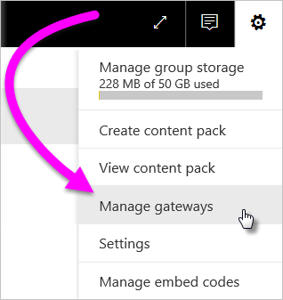

**Note**

**Manage gateways** will not show up until you're the admin of at least one gateway. You become an admin either by being added as an admin or because you installed and configured a gateway.

## Manage gateway admins

When you install a gateway, you are by default an admin of that gateway. You then add additional users or security groups as admins by using the **Administrators** tab for the gateway. You also use this tab to remove admins.

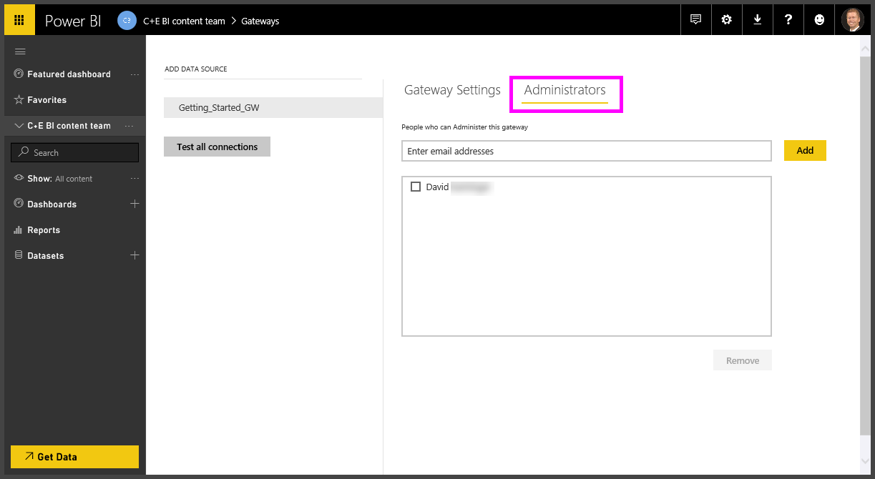

**Note**

Security groups without email addresses can't be added.

## Remove or delete an on-premises data gateway

1. In the upper-right corner of the Power BI service, select the gear icon Settings gear icon. > **Manage gateways**.
2. Select the gateway and then select **Remove**.

